html Assignment

1.Are the HTML tags and elements the same thing?

ans;no, HTML tag is just opening or closing entity. For example:<p> and </p> are called HTML tags

HTML element encompasses opening tag, closing tag, and content Eg:

<p>This is the content</p> : This complete thing is called a HTML element

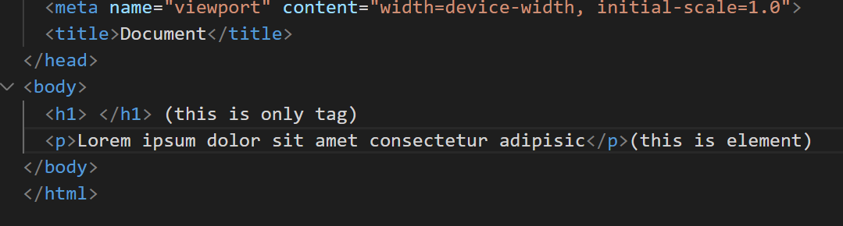

2. What are tags and attributes in HTML?

ans;

Html tags define to your web browser the format and display of your web page.

<Input> and <video> are tags

Attributes are used inside an HTML tag to specify additional information about the tag

Loop,autoplay,muted,controls are video tag attributes

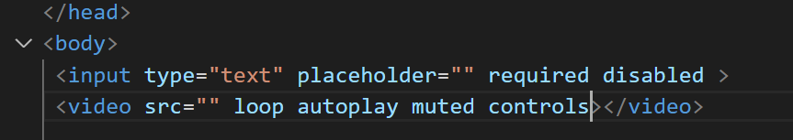

3.What are void elements in HTML? With Example

ans:A void element is an element whose content model never allows it to have contents under any circumstances. Void elements can have attributes. The following is a complete list of the void elements in HTML : area , base , br , col , command , embed , hr , img , input , keygen , link , meta , param , source , track , wbr.

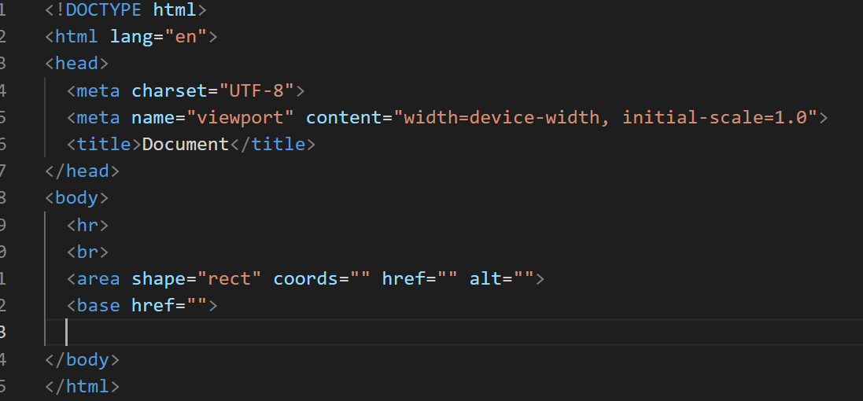

4.What are HTML Entities? With Example.

ans; HTML entities are the reserved characters that have special meaning when used in an HTML document.

exmample code;

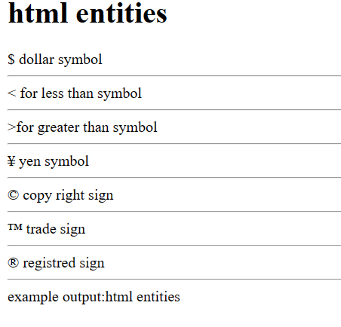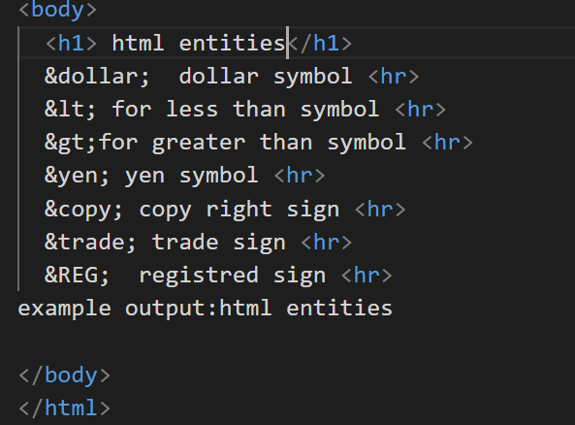

5. What are different types of lists in HTML? With Example.

ans:There are three types of lists in HTML

Ordered lists

Unordered lists (the one being used in this list too)

Definition lists

exmple code: three types list in html 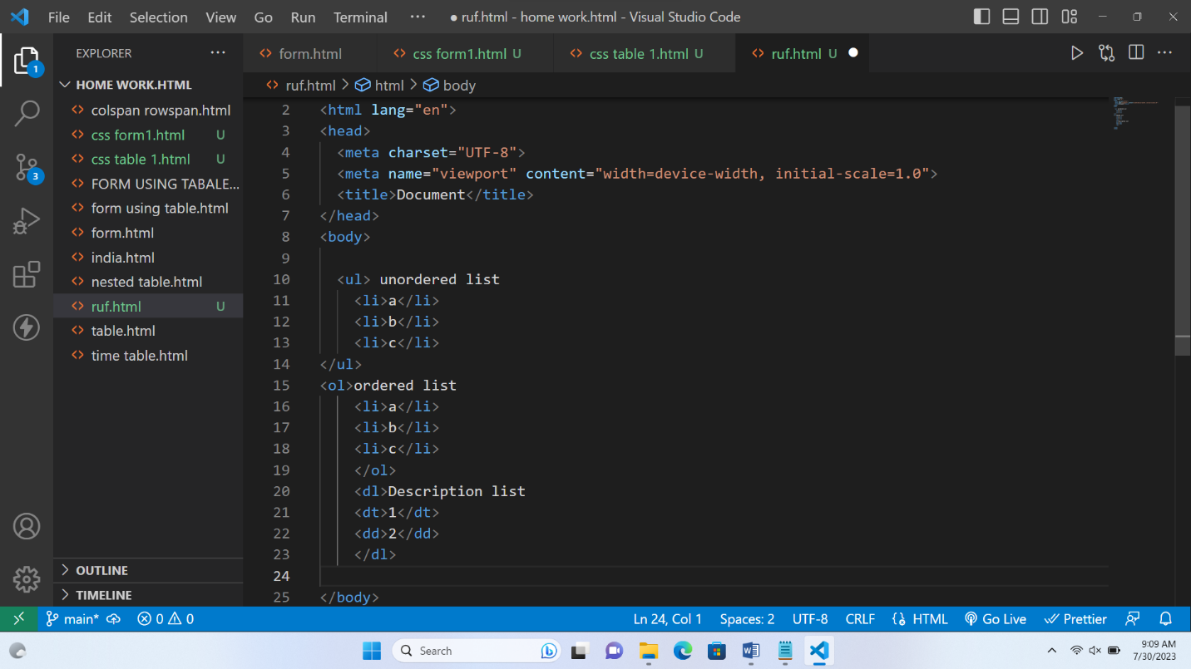example output:

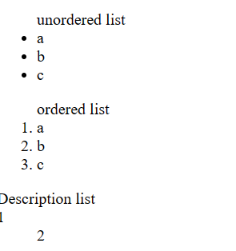

6• What is the ‘class’ attribute in HTML? With Example.

ans:The HTML class attribute is used to specify one or more class names for an element.

exampale:

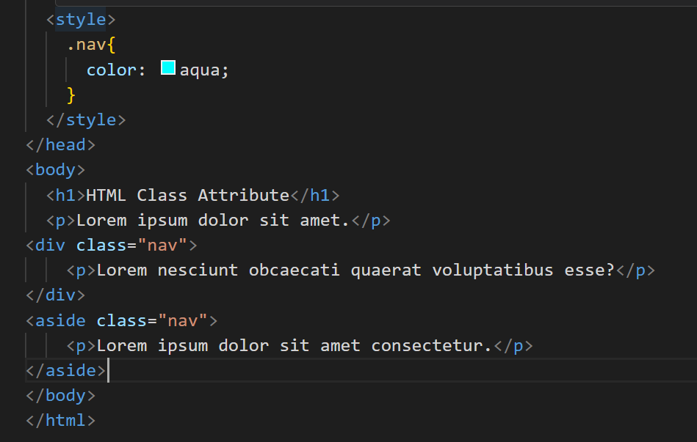

example output:

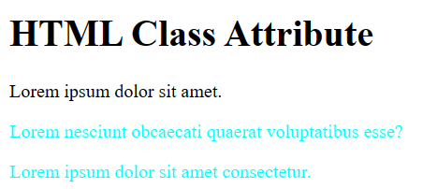

7.• What is the difference between the ‘id’ attribute and the ‘class’ attribute of HTML

elements? With Example.

ans:The difference between ID and class is that ID is used to identify only one element in our HTML. An ID is only used when an element on the page should have a specific style applied to it. However, a class can be used to identify more than one HTML element.

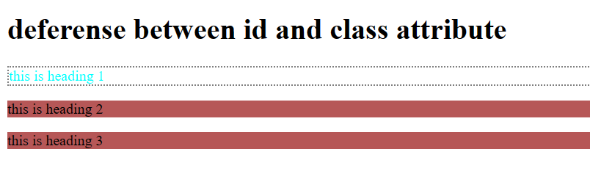

Example: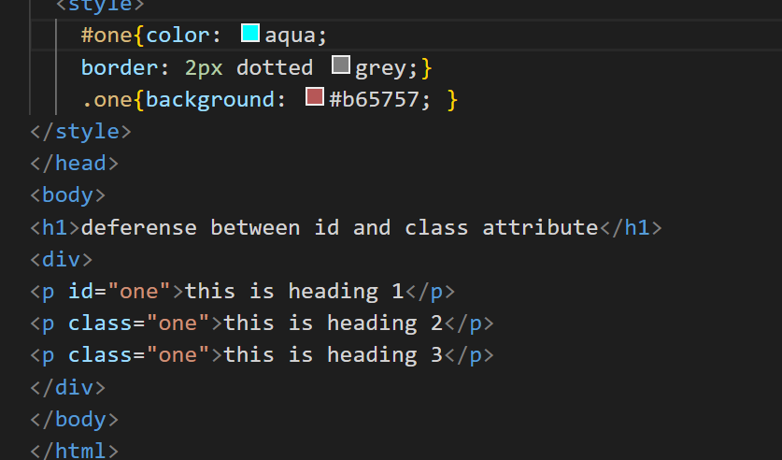

8.What are the various formatting tags in HTML?

ans:HTML Formatting is a process of formatting text for better look and feel. HTML provides us ability to format text without using CSS.

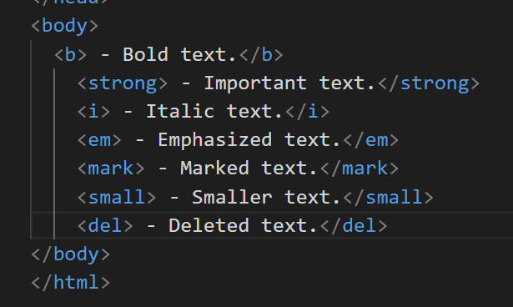



9.How is Cell Padding different from Cell Spacing? With Example

ans:Cellpadding specifies the space between the border of a table cell and its contents

Cellspacing specifies the space between cells

Example: 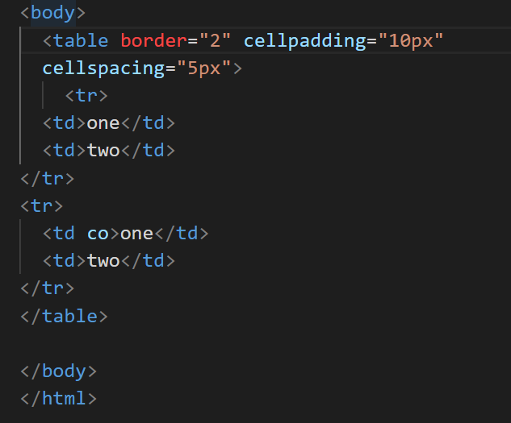

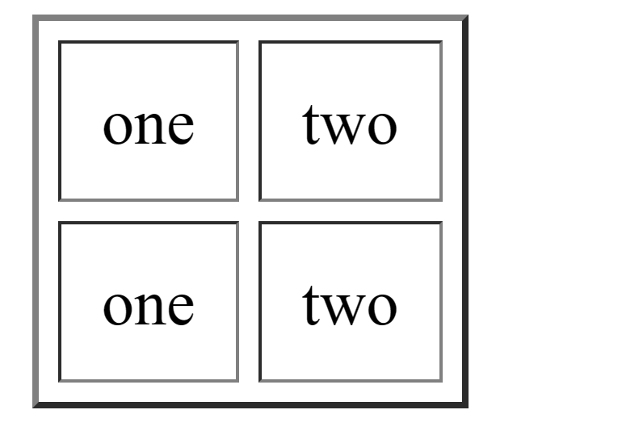

10.How can we club two or more rows or columns into a single row or column in an HTML

table? With Example

ans:We can use the colspan and rowspan attribute, to merge cells in HTML. The rowspan attribute is for the number of rows a cell should merge, ane the colspan attribute is for the number of columns a cell should merge.

example:

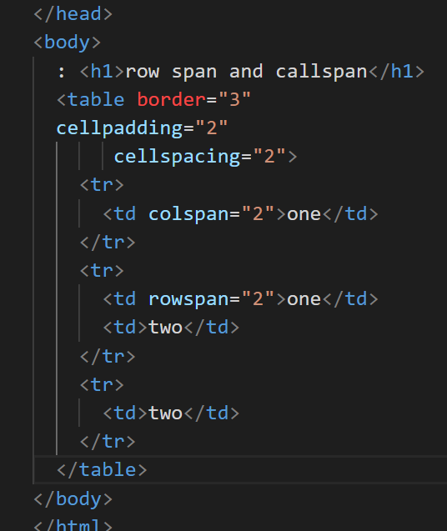

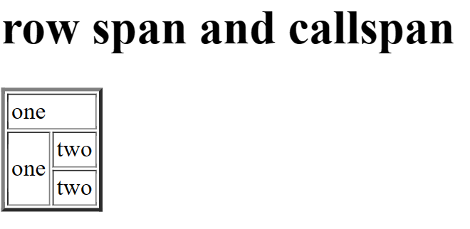

11.• What is the difference between a block-level element and an inline element?

ans:Block elements always start from a new line. Inline elements never start from a new line. Block elements cover space from left to right as far as it can go. Inline elements only cover the space as bounded by the tags in the HTML element.

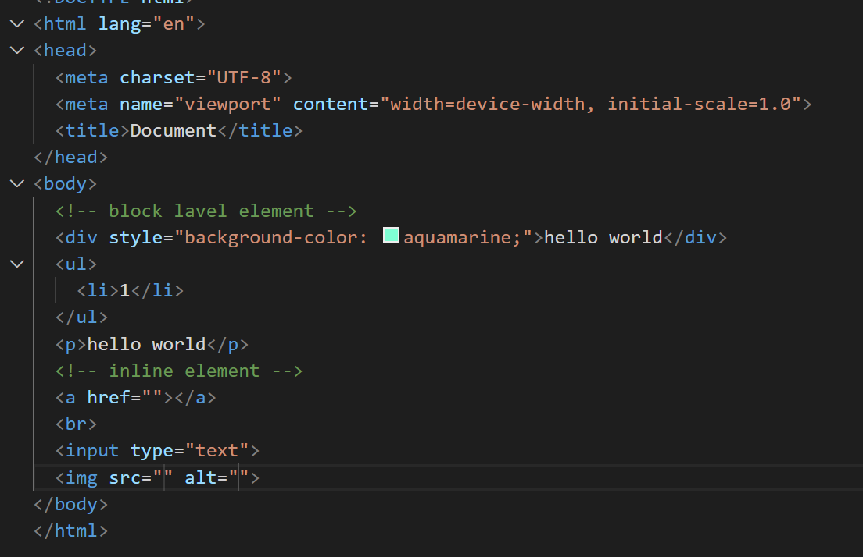

12.• How to create a Hyperlink in HTML? With Example

ans:How can we create a hyperlink in HTML with an example?

To make a hyperlink in an HTML page, use the <a> and </a> tags, which are the tags used to define the links. The <a> tag indicates where the hyperlink starts and the </a> tag indicates where it ends.

Exampale:

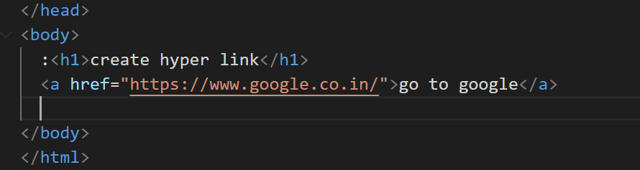

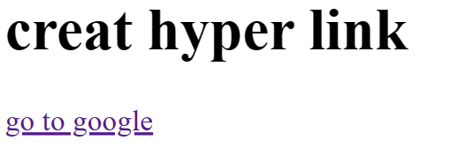

13.What is the use of an iframe tag? With Example.

ans:The <iframe> tag specifies an inline frame.

An inline frame is used to embed another document within the current HTML document.

Example:

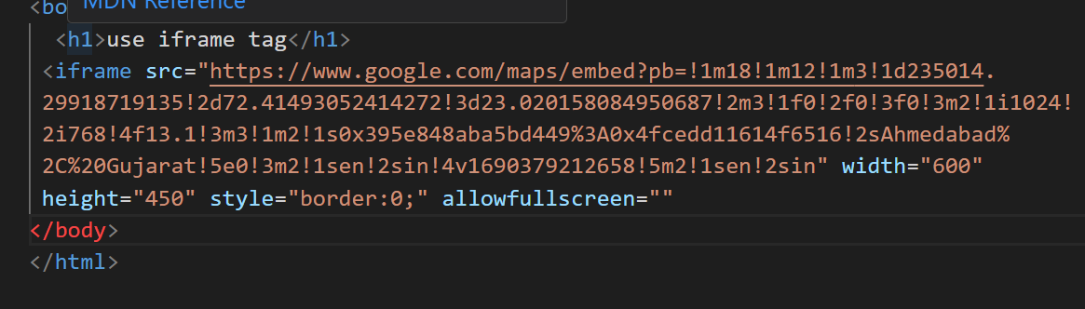

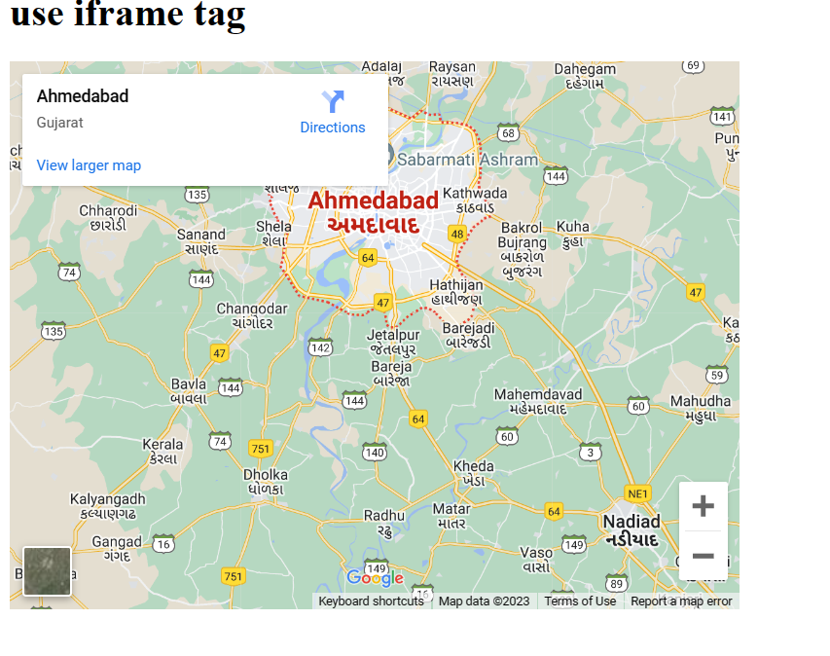

14.What is the use of a span tag? Explain with example?

ans:the <span> tag is an inline container used to mark up a part of a text, or a part of a document.

Emaple:

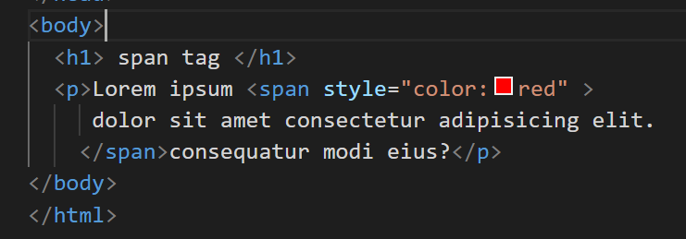

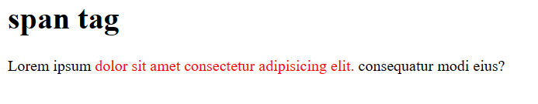

15.How to insert a picture into a background image of a web page? With Example

ans:Background Image on a HTML element

To add a background image on an HTML element, use the HTML style attribute and the CSS background-image property:

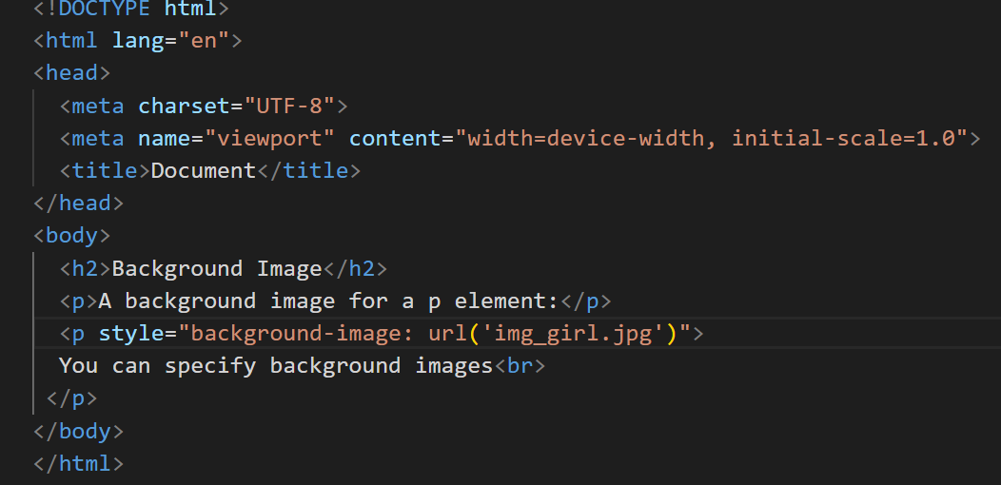

16.How are active links different from normal links?

ans:Normal links are links which are there on the page and have not been clicked yet. Active links are those links, have just been clicked at that instant.

17.What are the different tags to separate sections of text?

ans:Three tags are used to separate the texts.

<br> tag - <br> tag is used to separate the line of text.

<p> tag -<p> tag contains the text in the form of a new paragraph.

<blockquote> tag - It is used to define a large quoted section.

18.What is SVG?

ans:SVG stands for Scalable Vector Graphics

19.What is difference between HTML and XHTML?

ans:Difference between HTML and XHTML :

S.No. HTML XHTML

1. HTML stands for Hypertext Markup Language. XHTML stands for Extensible Hypertext Markup Language.

2. It was developed by Tim Berners-Lee. It was developed by W3C i.e World Wide Web Consortium.

3. It was developed in 1991. It was released in 2000.

4. It is extended from SGML. It is extended from XML and HTML.

5. The format is a document file format. The format is a markup language.

20.What are logical and physical tags in HTML

ANS: **Logical tags :** Logical tags are used to tell the meaning of the enclosed text.

**Physical tags :** Physical tags are used to tell the browser how to display the text enclosed in the physical tag.